Press release

Stuttgart, August 31, 2021
MAHLE achieves turnaround
- In the first half of 2021, sales grew by 32 percent, more strongly than the market
- Turnaround achieved with positive consolidated result
- Many risks give reason to expect more volatile second half of 2021
- MAHLE CEO Michael Frick: “We have become more profitable and offer powerful new technologies for sustainable mobility.”
- IAA Mobility: MAHLE focuses on e-mobility – from charging infrastructure via battery systems to electric drives

In the first half of 2021, automotive component supplier MAHLE significantly boosted sales and earnings. From January to June 2021, consolidated sales grew by 32 percent – or 36 percent following adjustment for exchange rate effects – to about EUR 5.7 billion. The technology group therefore grew faster than the global automobile market. The highest growth rates were recorded in the Electronics and Mechatronics business area. EBIT for the first half was about EUR 201 million, after MAHLE had recorded a negative result in the first half of 2020 – also as a result of Covid-19. Increased sales, productivity along with numerous initiatives to reduce costs offset negative effects such as higher material prices. The consolidated result after taxes was also positive again, at EUR 55 million. “We have therefore achieved the turnaround we had aimed for. The positive figures confirm that we have become more profitable and more efficient in overall terms,” said Michael Frick, Chairman of the Group Management Board (ad interim) and CFO of MAHLE, presenting the half-year figures. The company headquartered in Stuttgart is more cautious as regards the second half. In view of various risks such as high raw material prices and semiconductor shortages, the second half could become more volatile. Nevertheless, MAHLE expects to close the entire year with sales growth and a positive result. At the IAA Mobility, MAHLE is presenting the next generation of e-mobility to the public in the “Open Space” at Munich’s Königsplatz and to its customers at the Mobility Summit (exhibition center).
“MAHLE has boosted the pace of its transformation. We will consistently build on the success achieved to date in our technological and structural reorientation,“ said Frick. One of the key elements in this success is high research and development expenditure, which amounts to about six percent of sales. Future-oriented technologies and fields connected with climate-neutral mobility account for more than 80 percent of this figure.
At the leading industry showcase IAA, the technology group is highlighting its broad-based positioning with respect to e-mobility, ranging from charging technology to battery systems and electric motors. “We are supporting energy flow through the entire vehicle and even start before we reach the vehicle,” said Vice President Corporate Research and Advanced Engineering Dr. Martin Berger. MAHLE supplies smart charging infrastructure in the form of chargeBIG. The almost 1,000 charging points installed for long-term parking are to receive a key boost from the “chargeBIG POWER” system of fast charging stations with power ratings up to 750kW.
However, fast charging not only calls for the right infrastructure. Vehicle technology, especially the battery, is equally important. For fast charging, temperatures within the battery cell must be evenly distributed and must not rise too high. “In this area, MAHLE has made a breakthrough. We have now succeeded in rolling back the boundaries of rapid charging to a considerable extent by opting for a new solution: immersion cooling,” said Berger. With this system, a non-conductive coolant circulates around the cells, the cables and all connectors of the battery. This reduces the maximum temperature and improves heat distribution within the battery cell. Charging in a matter of minutes at the same time as longer battery life improves the suitability of electric vehicles for long trips and therefore public acceptance of this technology. Customers are highly interested. MAHLE expects the system to be introduced on battery-electric vehicles from 2025 onwards.
The new magnet-free electric motor from MAHLE represent a breakthrough in electric motor development. This electric motor does not need rare earth elements. This not only makes production more environmentally compatible but also brings benefits in terms of cost and raw material security. The key feature of the new motor is inductive, contactless power transmission – as a result, the motor operates without wear and is highly efficient over a wide speed range. At the drive system operating points most used, efficiency is over 95 percent – a value only achieved by Formula E racing cars to date. MAHLE has therefore succeeded in combining the advantages of various different electric motor designs in a single product. This new development is easily scalable and can be used on a wide range of vehicles from small cars to trucks.
Thermal management, i.e. heating and cooling, still remains the business area of MAHLE with by far the largest share in sales. Thanks to technologies from MAHLE, power electronics, motors and batteries are protected against damage and vehicle interiors are maintained at comfortable temperatures.
“We have the advantage of a very wide range of products. In many cases, these can rapidly be transferred from conventional internal combustion engines to e-mobility applications,“ said Frick, outlining the prospects for MAHLE. By 2030, the company intends to boost the share of sales generated independently from internal combustion engines for passenger cars from the present figure of 60 percent to 75 percent.

Key figures of MAHLE GmbH compared with the prior-year period
 | First half  2020 | First half  2021
Sales (in million euros) | 4,278 | 5,661
EBIT (in million euros) | -146.1 | 200.6
EBIT-Margin (in percent) | -3.4 | 3.5
Net income (in million euros) | -292.8 | 54.9
Net debt (as of reporting date)¹ in million euros | 925 | 920

¹ Reporting date: December 31, 2020 or June 30, 2021

Note for journalists: you will find audio statements related to this press release at https://www.mahle.com/de/news-and-press/press-releases/.

Copyright: MAHLE GmbH
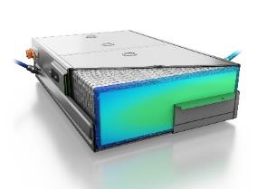 | 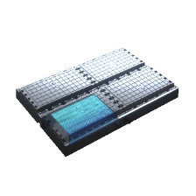 | 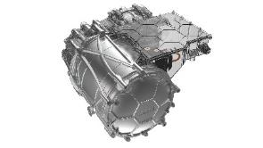
Ideal temperature and homogeneous distribution. With the MAHLE immersion cooling system, charging times can be shortened and battery size reduced. | Immersion cooling significantly reduces charging times for electric car batteries. To charge batteries fast, heat must be evenly distributed inside the battery cell and the temperature must not rise too high. | The new MAHLE traction motor is wear-free, compact and does not require rare earth minerals. The innovation leap is tremendous – comparable with the shift from intake pipe to direct gasoline injection.
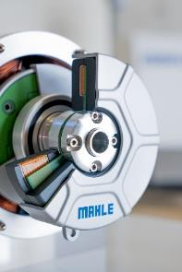 |  | 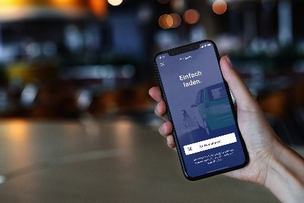
The new magnet-free electric motor features high durability. Power transmission between the rotating and stationary components of the motor is completed without contacts and without wear. | MAHLE gives the bike its DNA back. Smart bike drive systems from MAHLE are inconspicuous and extremely light. | chargeBIG, the smart charging system from MAHLE, is the first system giving an indication on a smart phone in accordance with German and weights and measures regulations. chargeBIG Power fast charging stations with power figures up to 750 kW are now being added to the system.
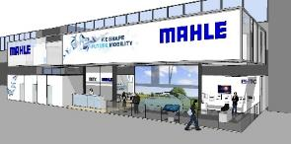 | 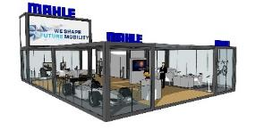 | 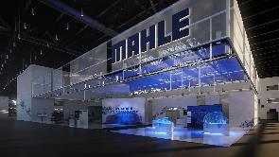
MAHLE is showcasing its wide range of products for e-mobility at the IAA Mobility in Munich. Munich Exhibition Centre, Hall B1, Booth C80 from September 6 to 12, 2021. | MAHLE is presenting the e-mobility of the future to the general public in the IAA Open Space at Königsplatz in Munich city centre. | MAHLE’s virtual show booth for the IAA is already opening on September 3, 2021. https://experience.mahle.com/

Contacts at MAHLE Communications:
Manuela Hoehne
Director Communications and Public Relations
Phone: +49 711 501-12506
E-Mail: manuela.hoehne@mahle.com
Ingo Schnaitmann
Spokesperson, Corporate Communications
Phone: +49 711 501-13185
E-Mail: ingo.schnaitmann@mahle.com

About MAHLE
MAHLE is a leading international development partner and supplier to the automotive industry. The technology group is now broadly positioned in the areas of powertrain technology and thermal management with a clear focus on future topics relating to mobility. As part of its dual strategy, MAHLE is working both on the intelligent combustion engine for the use of hydrogen and other nonfossil fuels and on technologies that will help the fuel cell and e-mobility achieve broad acceptance in the markets. The product portfolio of the company, which was founded in 1920, addresses all the crucial aspects of the powertrain and air conditioning technology. Half of all vehicles in the world now contain MAHLE components. #weshapefuturemobility
In 2020, MAHLE generated sales of approximately EUR 9.8 billion and is represented in over 30 countries with more than 72,000 employees in 160 production locations and 12 major research and development centers. (Last revised: 2020-12-31)

